Energy Storage Capacity Analysis
Norbert Doerry
June 15, 2026
- Introduction
Energy storage within an electrical power system may be employed to fulfill a variety of functions. The properties of the energy storage should reflect the capabilities of the technologies used to implement the energy storage and the particular requirements of the functions the energy storage is intended to fulfill. The three major energy storage technologies considered for shipboard power systems are batteries, flywheels, and super-capacitors. As depicted in Figure 1, the technologies offer trade-offs in optimizing mass with respect to energy and power. Additionally, each technology has associated, but different, safety considerations that should be addressed in the ship design.
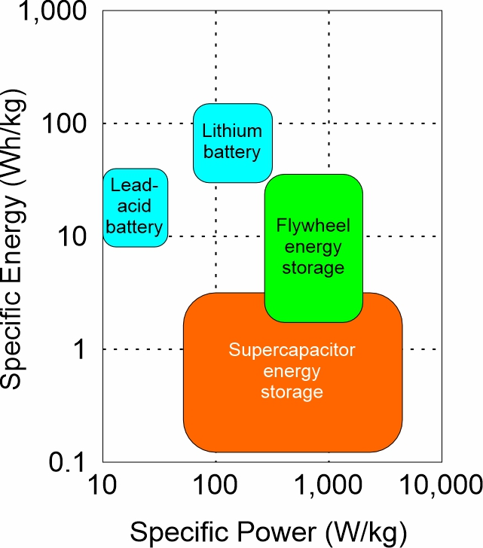
Figure 1: Ragone plot of energy storage technologies (approximate)
- Energy Storage Functions
The following energy storage functions are an extension of those defined by Doerry and Amy (2011).
  - ESM-F1
Energy storage fulfilling ESM-F1 provide power of the requisite power quality to loads (uninterruptible loads primarily) during short term power disruptions of up to the reconfiguration time (t1). ESM-F1 is typically accomplished using an uninterruptible power supply (UPS) limited to supplying power to one or a few loads.
  - ESM-F2
Energy storage fulfilling ESM-F2 provide power of the requisite power quality to loads (uninterruptible and short term interrupt loads or emergency loads) during power disruptions of up to the generator start time (t2).
ESM-F2 fulfills the functions of a temporary emergency power source as defined in 46 CFR 112.01-15. Passenger vessels traveling on the ocean, Great Lakes, or coastwise, or on an international voyage, are required to have a temporary emergency power source. ESM-F2 fulfilling the functions of a temporary emergency power system must have sufficient energy capacity to supply temporary emergency loads for at least 30 minutes.
  - ESM-F3
Energy storage fulfilling ESM-F3 provide power for the emergency starting of generator sets. 46 CFR 112.50-1 requires sufficient capacity to provide for six consecutive starts.
  - ESM-F4
Energy storage fulfilling ESM-F4 provide load leveling for pulsed loads, generator sets with slow dynamics, and generator sets operating near their capacity.
2.5 ESM-F5
Energy storage fulfilling ESM-F4 provide primary power with or without other generator sets online. Used to implement zonal or compartment system survivability. Also used when limiting airborne emissions in sensitive environments, or when limiting infrared or acoustic signatures for limited periods of time.
- Energy Storage Technologies
  - Batteries
Batteries are the most common technology used for energy storage onboard ship today. Low power UPSs have historically used lead acid batteries, but lithium-based batteries are increasing being used in these applications. Battery energy storage systems (BESS) intended for higher power and energy capacity are increasingly using lithium-based batteries. Higher power battery systems incorporate series and parallel configurations of individual battery cells along with a battery management system to monitor and optimize the battery’s SOC and SOH while ensuring safety. To maximize battery life, batteries typically are not fully charged or discharged, resulting in a working capacity less than the rated capacity. Generally, lithium based batteries should not be discharged below 20% state-of-charge (SOC) (minimum operating SOC). Lithium ion batteries last longer if charging is stopped at 80% SOC (maximum operating SOC). Lithium Iron Phosphate batteries may be charged to 100% SOC. Hence the useable energy capacity for lithium ion battery is 60% of its rating; and for lithium iron phosphate it is 80% of its rating.
The end of life of a battery is usually defined as when the energy capacity has degraded to 80% of its capacity when new; the degree of degradation that a battery has experienced is called state of health (SOH). To ensure the battery will be able to fulfill its function until replaced, the calculated capacity should also be multiplied by 1.25 to account for the SOH being 80% at end of life.
Applying corrections for useable energy capacity and SOH, the calculated energy requirement for a lithium ion battery should be multiplied by 2.1 to obtain the required battery energy requirement. Similarly, the calculated energy requirement for a lithium iron phosphate battery should be multiplied by 1.6 to obtain the required battery energy requirement. These factors should be modified if information on applicable datasheets indicates other values should be used.
Lead acid batteries should normally have a charge between 50% and fully charged. Unless data sheets indicate otherwise, the calculated energy requirement for a lead acid battery should be multiplied by 2.5 to obtain the required battery energy requirement.
One of the key factors for end of life is the number of charge and discharge cycles. Different battery technologies and battery design details result in different numbers of charge and discharge cycles before the end-of-life condition is met. Datasheets should be consulted to determine the number of charge and discharge cycles the manufacturer expects the battery to be capable of before meeting the end-of-life condition. In most cases, the end-of-life for the batteries is less than the service life of the ship; provisions should be provided to easily replace the batteries. (Figure 2)
Large batteries usually require special off-gas vent systems, cooling systems, and firefighting systems.
See IEEE Std 45.1, ABS (2025) and Sun, Patel and Hou (2020) for additional details on battery installations onboard ship.
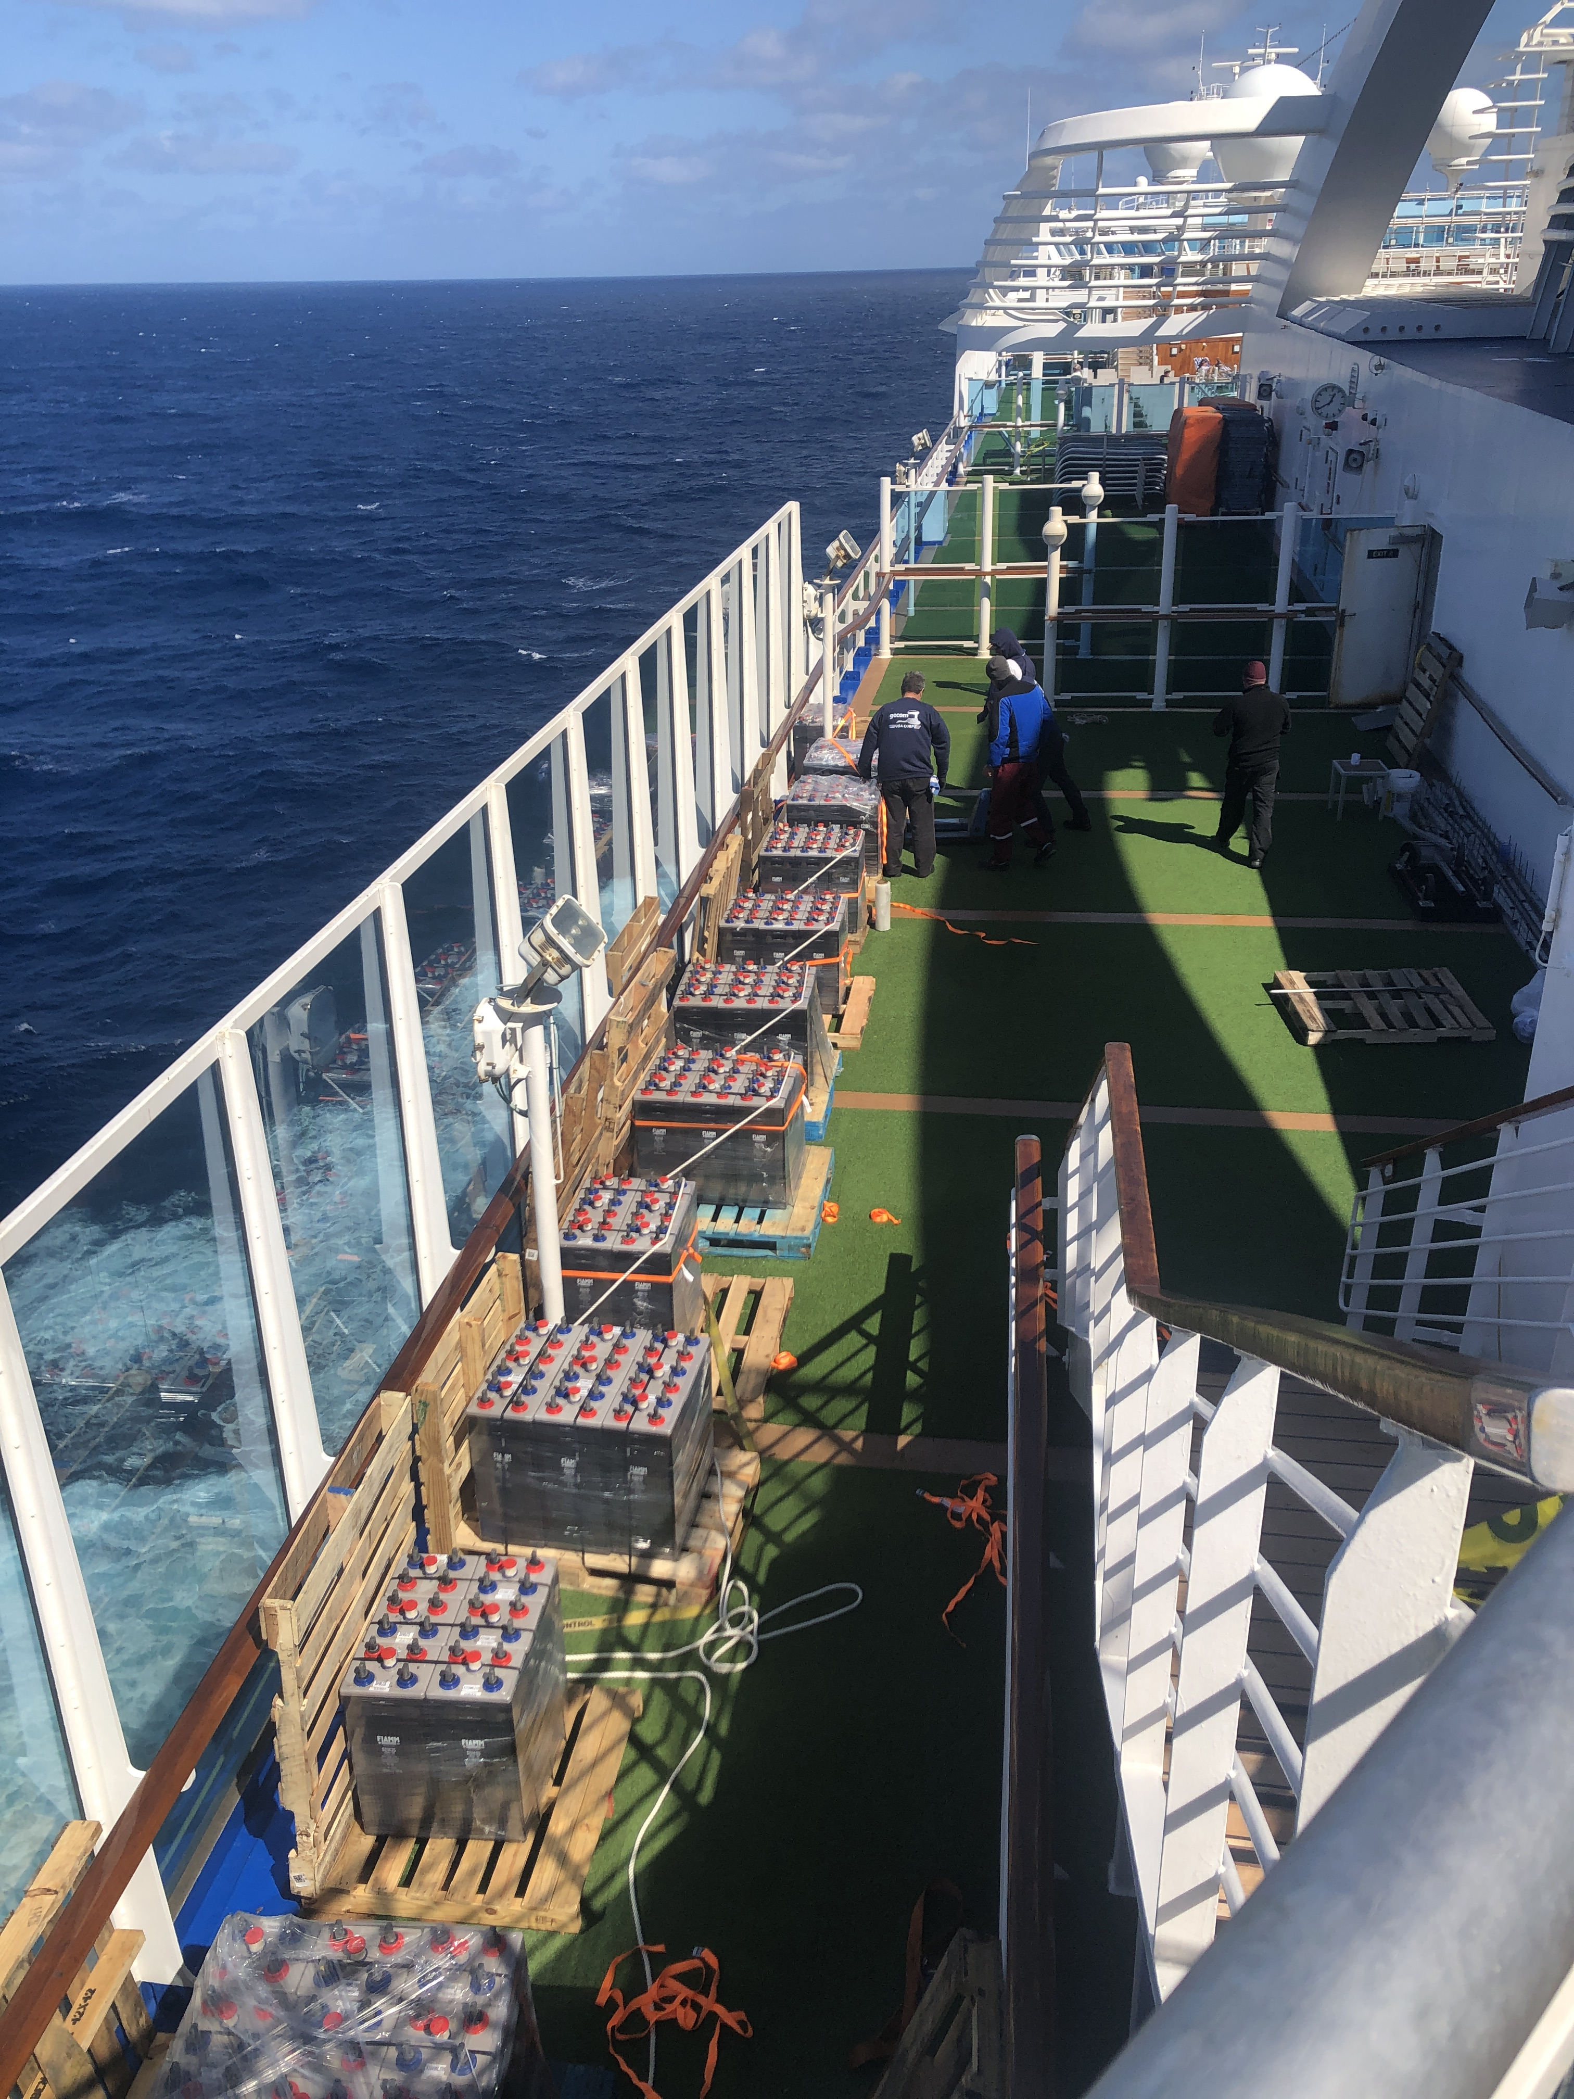
Figure 2: Batteries staged for replacement on Ruby Princess (2024 Photo by Norbert Doerry)
  - Flywheels
Flywheels use rotational kinetic energy to store energy. A combination motor/generator driven by a bi-directional power electronic converter performs the conversion between electrical energy and rotational kinetic energy. Compared to lithium batteries, flywheels usually can support higher charge and discharge rates but have lower energy capacity. Flywheels can be designed to have a service life consistent with the service life of the ship; they may not require replacement during the ship’s life. Commercial flywheels are available with a stated service life in excess of 20 years. While a flywheel is likely to be more expensive than the initial installation cost of a comparable battery system, the need to replace the batteries multiple times over the ship’s life may result in the flywheel having a lower total ownership cost.
The rated energy of a flywheel may not be the maximum amount of electrical energy that can be extracted from the flywheel (maximum useable energy). Datasheets should be closely examined to determine if the rated energy is the maximum kinetic energy that can be stored, or the maximum useable energy. Flywheels typically are not allowed to slow down below 50 to 70% of their rated speed. Additionally, some of the energy is lost in power conversion. The maximum useable energy may be about 45 to 70% of the maximum kinetic energy.
See Sun, Patel and Hou (2020) for additional information on shipboard flywheel applications
  - Super-Capacitors
A super-capacitor stores electrical energy in the electric field of the capacitor. Super-capacitors have very high charge and discharge rates, but their energy density is typically lower than batteries or flywheels. Similar to a BESS, a capacitor energy storage system is composed of series and parallel combinations of individual supercapacitors and employs a capacitor management system. Individual supercapacitors are commercially available with capacitances in the 100’s of Farads, but with a rated maximum voltage only between 2.5 and 3 volts.
The energy stored in a capacitor (E_{capacitor}) is given by:
$$E_{capacitor}=\frac{1}{2}CV^{2}$$
Where
C = capacitance
V = voltage
The useable energy is the difference between the energy when the voltage is at its maximum operating voltage and when it is at its minimum operating voltage, reduced by the losses in the effective series resistance (ESR) when discharging.
The life of a supercapacitor depends on both the temperature and the voltage. The life roughly doubles for every 10° C decrease in temperature or 0.1 volt decrease in voltage. A typical life of a super capacitor is 1500 hours at the rated temperature (typically 60 to 65° C) and rated voltage (3 Volts is not unusual). The end of life is usually established as a loss of 20 to 30% of rated capacitance. Datasheets should be consulted for the properties of a given supercapacitor.
If the capacitors can be kept cool, and the maximum operating voltage is kept near a half a volt less than the rated voltage, the life of a super capacitor could exceed 150,000 hours;
The minimum capacitance value is initially chosen based on the minimum and maximum operating voltages, the ESR, and the current discharge profile. The minimum and maximum operating voltage have corresponding minimum and maximum operating SOCs. Since capacitors typically have a 20% tolerance, and the capacitance may degrade with time, the minimum capacitance value should be multiplied by about 1.8 when selecting a capacitor in order to confidently meet the energy storage needs over time.
See ABS (2022) and Sun, Patel and Hou (2020) for additional information on shipboard super capacitor applications.
- Quasi-steady state analysis
Many of the analyses used to support determining required energy storage capacity employ quasi-steady state analysis. In quasi-steady state analysis, only dynamics slower than about one second are considered. Faster, transient dynamics are not modeled because the energy associated with these transients is usually only a small fraction of the overall energy requirement. A simple quasi-steady state analysis may only consider power flows as a function of time; voltages are assumed to be near the nominal system voltage. Alternately the quasi-steady state analysis can perform a load flow analysis at each time increment to calculate both the power flow and the voltage magnitudes.
To simplify analysis, any of the calculated interface values (such as voltages, current, or power) that depend on the state-of-charge (or any other state variable), use the state-of-charge (state variable) at the beginning of a time increment. The state of charge (state variable) at the end of a time increment may be calculated after a system solution is iteratively obtained.
The quasi-steady-state models of the energy storage systems should track the number of charge-discharge cycles the energy storage system has experienced since the start of the simulation. This number can be compared to the rated number of charge-discharge cycles to determine an upper bound on the expected life of the energy storage system. For batteries and supercapacitors, the model could include temperature to better understand the impact of the energy storage environment on expected life.
- Energy Storage analysis
  - UPS vs fast circuit breaker studies (ESM-F1)
One design trade-off that may be considered is employing fast circuit breakers to minimize the number and rating of uninterruptible power supplies (UPS). If circuit breakers can isolate a fault very quickly, say in under 5 ms, then few if any loads would suffer a service interruption due to a short duration power disruption from fault isolation. The cost of circuit breakers that can achieve a fault clearing time of 5 ms cost more than circuit breakers with a longer clearing time. The cost differential of the circuit breakers should be compared to the cost of the UPS needed to prevent a service interruption.
The study consists of identifying the speed (t1) that different approaches to fault detection, localization and isolation can achieve and comparing this time to the duration of a power disruption that loads can tolerate. If the loads can tolerate longer disruptions, then no further design effort is needed. If certain loads cannot tolerate the disruptions, then UPSs should be considered to isolate the load from the power disruption.
  - Standby generator start simulation (ESM-F2)
This scenario assumes that initially there are at least two generator sets online. At some point, one of the generator sets trips offline and the remaining online generator sets do not have sufficient capacity to serve all the loads. Typically, the study employs quasi-steady state simulation to evaluate the system response. The simulation should model load shedding; the control algorithms intended to implement the load shedding should be modeled. The energy storage is evaluated to determine if its power and energy capacity ratings are sufficient.
Some electrical power is required to start the standby generator. Under this scenario, energy storage could be dedicated to starting the standby generator, similar to an emergency diesel generator set. Sufficient energy and power should be provided for six consecutive starts. If the same energy storage system is used for both ship service loads and standby generator starting, then the control system should allocate sufficient energy storage capacity to provide six consecutive starts; this allocated energy storage should not be used for ship service loads.
The simulation should include modeling the recharging of the energy storage once the standby generator is online.
Within this study one can trade-off centralized and decentralized energy storage. If decentralized energy storage is already required for ESM-F1 functionality and this decentralized energy storage has enough capacity for ESM-F2 functionality, it makes sense to take advantage of this energy storage. Any additional demand for energy storage could be fulfilled by either centralized or decentralized energy storage.
If the quasi-steady-state simulation incorporates stochastic models, the model should be simulated many times to ensure sufficient capacity for both power and energy is provided by the energy storage system.
These quasi-steady simulations differ from load analysis for 24-hour average or power system equipment sizing in that the in the latter cases, a single operating condition is modeled; time-based variation is typically due to cycling loads. For this analysis, the system is in transition from an initial operating point following the loss of an online generator set to a long-term stable operation with a standby generator set online that restores generation capacity.
  - Reserve power studies (ESM-F2)
Reserve power is online generation capacity (power) that is available but not being used. Reserve power includes energy storage designated for ESM-F2 functionality. Reserve power studies typically examine the following scenario: The total load increases significantly to a level beyond the rating of online generator sets. Energy storage provides power until one or more standby generators are brought online to service the new total load and charge the energy storage.
The system response may include load shedding of lower priority loads. If this is the case, the load shedding algorithms and hardware should be modeled.
A quasi-steady state analysis is used to evaluate the adequacy of the energy storage power and energy capacity. The modeling techniques are essentially the same as for the previous standby generator start simulation. Once again, the simulation is modeling a transition from an initial condition where there is insufficient online generation to the condition where the standby generator is brought online to restore sufficient generation capacity.
  - Dark ship start simulation (ESM-F2 and ESM-F3)
A dark ship occurs when all online generator sets trip offline, but energy storage is available. This may occur for example, if a single generator set is operating with energy storage providing reserve power. It could also happen if two generator sets are initially online, but both trip offline nearly simultaneously.
A quasi-steady state simulation is used to evaluate the adequacy of the energy storage power and energy capacity. Generally, the system responds by shedding load, starting the emergency generator set and the standby generator sets, and using energy storage to supply power to remaining loads. Once the standby generator sets are online, the energy storage switches from discharging to charging. The simulation evaluates whether the proper loads have been shed (not shed) and that the correct loads to enable the standby generator sets to start and operate are provided power. The simulation is modeling a transition from an initial condition where there is no generation online, to the condition where the emergency and standby generator(s) are brought online to restore sufficient generation capacity
Some or all of the energy storage may comprise a temporary emergency power source in accordance with 46 CFR 112.15. A temporary emergency power source is required for passenger vessels in service on the ocean, Great Lakes, or coastwise; or on an international voyage.
  - Load-leveling study (ESM-F4)
A load-leveling study is used to examine several scenarios where load-leveling may be used. These scenarios include:
a. Enabling sources (such as fuel cells) that are not capable of fast enough dynamic response to achieve power quality requirements by themselves. Energy storage essentially serves as a low pass filter by supplying and receiving the high frequency content of the power, thereby enabling the source to only provide the low frequency content. The power rating of the energy storage system (both charging and discharging) should be greater than the largest step load change or near-step load change that power system experiences. A near step load change is one that occurs faster than the time constant of the source. The long-term average of the SOC for the ESS should be midway between the minimum and maximum operating SOC. The quasi-steady state (or full transient) analysis of the power system should provide the necessary energy rating of the energy storage system so that the SOC is very unlikely to be outside of the minimum and maximum operational SOC. Similar to load analysis for sizing power system equipment, this analysis concentrates on a single operational condition; variations in load are largely due to cycling loads.
b. Enabling sources to operate near their power rating by providing power when the load temporarily exceeds the power rating of the sources. The sources provide the average power up to their rating while the energy storage provides (either sources or sinks) the momentary deviations from that average power. Quasi-steady state simulation is used to determine the magnitude of the power excursion above the mean value as well as the maximum energy provided or received. If the average load exceeds the source rating, additional sources should be brought online. The maximum energy provided by the energy storage system should include the energy provided while the additional generator set is brought online.
c. Compensating for pulsed loads by providing (either sourcing or sinking) the deviations around the average power for the pulsed load. Depending on the details of the scenario, these studies may employ either quasi-steady state analysis or a full transient analysis.
  - Zonal and compartment survivability analysis (ESM F-5)
Zonal survivability analysis evaluates whether there is sufficient power generation, energy storage and connectivity in each zone to enable zonal survivability. In zonal survivability analysis, each zone and pair of adjacent zones is examined separately. One assumes the zone(s) are damaged and evaluates whether there is sufficient generation and connectivity in the undamaged zones to power all surviving mission critical equipment. If the architecture incorporates multiple cross-zone busses (typically port and starboard) that are sufficiently separated and protected such that the likelihood of both busses being inoperative is low, then one normally assumes one of the two busses will be operable following damage. Energy storage may be employed to provide power to an otherwise underpowered zone if it has sufficient connectivity and energy capacity. The energy capacity should be sufficient to last until an alternate means (such as casualty power) is employed to provide sufficient long term power to the zone. If restoring long term power to the zone is not practical, then one should consider using the requirement for an emergency power source detailed in 46 CFR 112.05-5.
Compartment survivability enables restoration of power to undamaged mission critical equipment within a damaged zone. This may be implemented with normal and alternate power feeds as well as the possible inclusion of casualty power. As with zonal survivability, if there is insufficient power capacity from generator sets in undamaged zones, then energy storage with the requisite energy capacity and power may be employed.
Since the time period for providing power is typically for an extended period of time, load factor analysis (24-hour average), stochastic analysis, or modeling and simulation analysis may be employed to determine the required energy requirement. Zonal load factor, stochastic analysis or modeling and simulation analysis should be considered for determining the energy storage system power requirement.
  - Endurance energy calculations (ESM F-5)
Endurance energy calculations are performed similar to endurance fuel calculations as defined in DPC 200-1. The economical transit distance and operational presence time are likely to be much smaller than for the fuel calculations. Instead of determining fuel rates and required fuel tank capacity, endurance energy calculations determine the power and energy capacity rating of energy storage. The useable capacity of the energy storage should be sufficient to meet the applicable endurance condition; the loads should include service life allowance and margins. The plant deterioration allowance should be consistent with the end-of-life loss in capacity (typically 1.25). Unless the energy storage is intended to be used in conjunction with generator sets, specific fuel consumption curves and tailpipe allowances are not applicable.
In calculating the 24 hour average load, load factor analysis, stochastic analysis, or modeling and simulation analysis are appropriate.
The following requirement are required:
- Economical transit
- Economical transit distance (nautical miles)
- Endurance speed (knots)
- Operational presence
- Operational mission
- Speed – time profile (knots vs. % time)
- Operational presence time (hours)
The following design details are needed:
  - 24-hour average electric load (averaged over an ambient condition profile)
  - Propulsion electric load as a function of ship speed
  - Plant deterioration allowance (degradation of energy storage over its life – use 1.25 unless data sheets indicate otherwise)
  - Sea State and fouling factor. For early stages of design, the default value of 1.10 is used for every speed. For later stages of design, the sea state and fouling factor should be determined for the intended operating area.
The Economical transit energy requirement (kW-h) is given by
$$\frac{Economical Transit Power \left(kW\right)×Economical Transit Distance \left(NM\right)×Plant Deterioration Allowance}{Endurance Speed (knots)}$$
Where:
$$Economical Transit Power \left(kW\right)=24 hour average electric load+propulsion electric load at endurance speed ×sea state and fouling factor$$
The maximum useable energy of the energy storage system should be no less than the Economical transit energy requirement
The Operational presence energy requirement (kW-h) is given by
$$Operational Presence Power \left(kW\right)×Operational Presnece Time \left(h\right)×Plant Deterioration Allowance$$
$$Operational Presence Power \left(kW\right)=24 hour average power+ \sum_{i=1}^{n}{{Profile_fraction}_{i}×{propulsion electric load}_{i}×sea state and fouling factor}$$
The maximum useable energy of the energy storage system should be no less than the Operational presence energy requirement
- References
IEEE Std 45.1 IEEE Recommended Practice for Electrical Installations on Shipboard—Design
ABS Requirements for Use of Lithium-ion Batteries in the Marine and Offshore Industries, December 2025.
ABS Requirements for Use of Supercapacitors in the Marine and Offshore Industries, July 2022.
DPC 200-1 Calculation of Surface Ship Endurance Fuel Requirements, 4 October 2011.
Doerry, Norbert, and John Amy, "Implementing Quality of Service in Shipboard Power System Design" presented at IEEE ESTS 2011 Alexandria VA.
Sun, Prof. Jing, Prof. Emeritus Mukund R. Patel and Dr. Jun Hou, Fuel Cells, Solar Power and Energy Storage, The Marine Engineering Series Edited by Michael G. Parson, SNAME, Alexandria VA, 2020 ISBN 978-1-7923-1231-1

